The College of Dental Surgeons of Hong Kong | 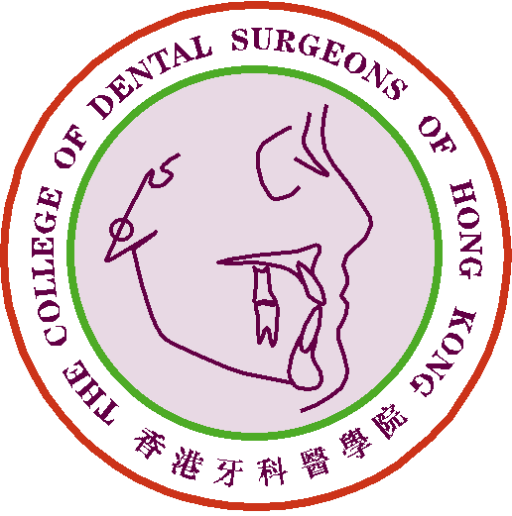

Claim Form for CME/CPD Programme

Personal Data |  | Date of Submission :
Name of Applicant : |  | Phone No.:
Email address: |  | DCHK No.:

Please ☑ one only:
1) Fellow or Specialist |  |  | 2) MGD Holder |  |  | 3) Specialist Trainee

Presenting in FCAA to Paramedical Personnel
Organization(s):
Name of activity:
Date of activity:
Mode of attendance: | Online/ Physical/ Dual mode (please delete as appropriate)
Duration as being a speaker in the claimed activity:
Number of attendees: | (The number of participants should be more than 10 and the name list should be submitted for accreditation.)
Please submit this claim form together with the attendance form to the College for processing.

For Official Use Only | Points Awarded:
For Official Use Only | Total | CME point(s)

- The CME Subcommittee has the rights to evaluate, approve, review and revise the CME point(s) for the above activity/activities.
- Please send this form and other supporting documents by e-mail: cme_cpd@cdshk.org to College for processing.

